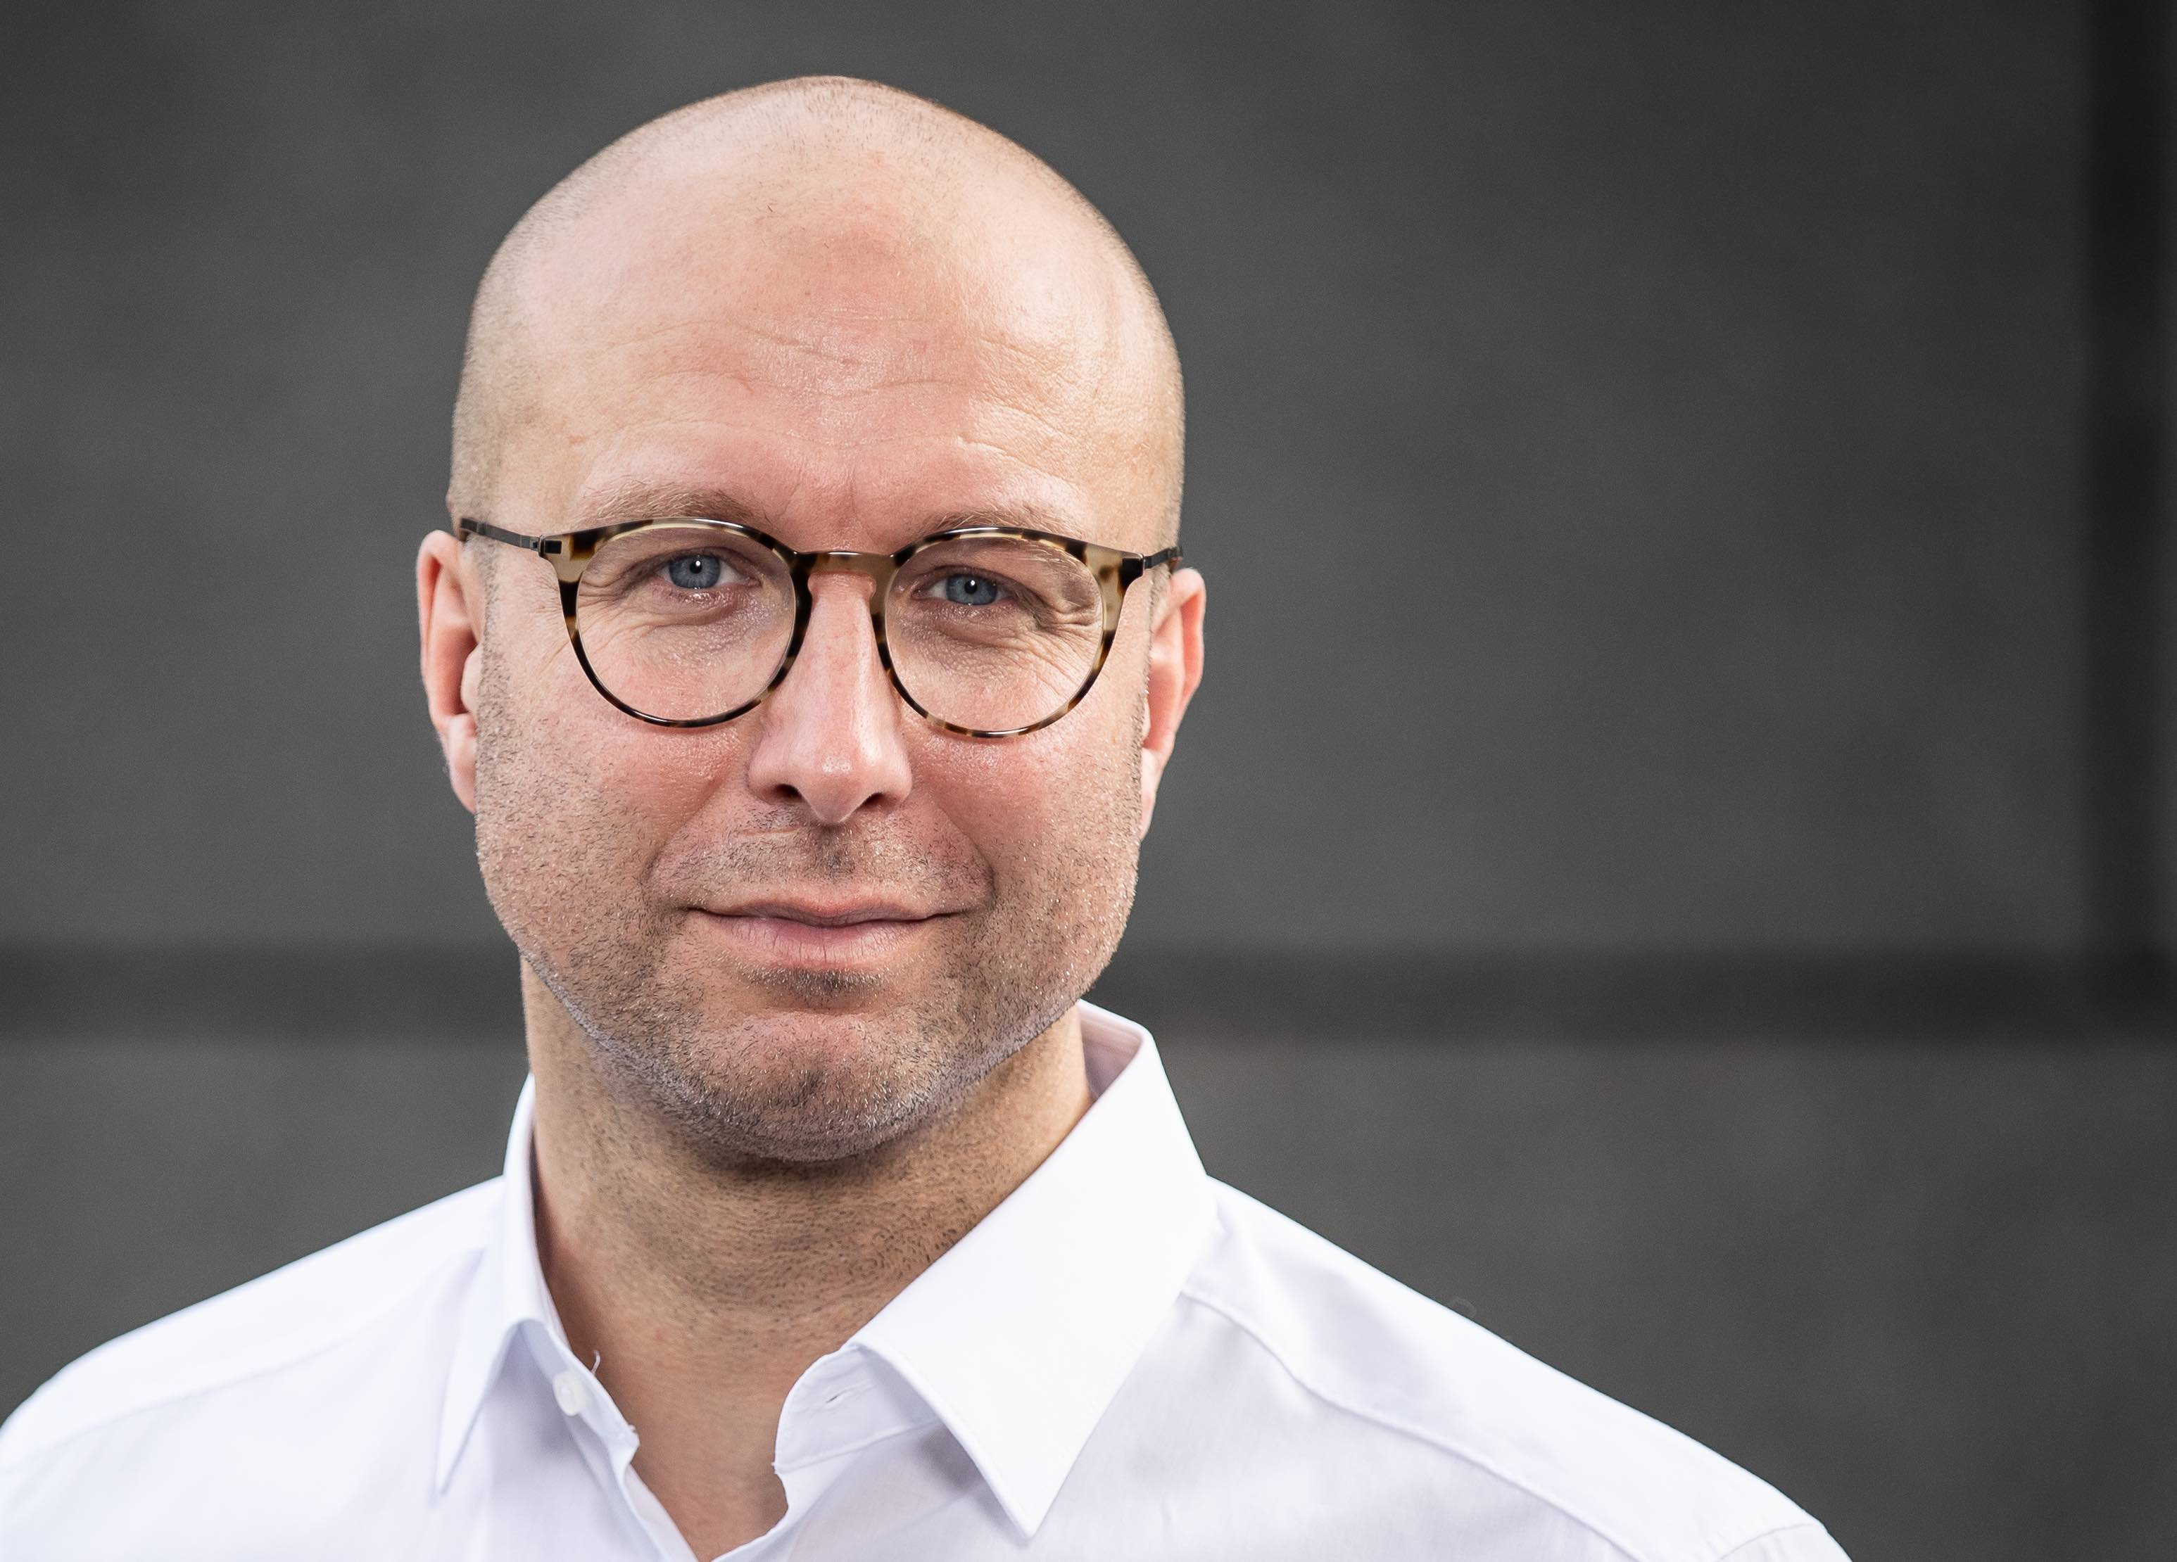
Sascha-Oliver Zöller

Business coach for data-driven business models -
More customers through automated lead generation
Marienweg 18; 50858 Cologne, P: +49 179 79 52 386,
Email: sz@saschazoeller.de Webside: www.saschazoeller.de
https://www.provenexpert.com/sascha-zoeller/

CURRICULUM VITAE
Personal Information | Date of Birth: 21. Juli 1970  married  German
Counsellor | since 1998
Language | - German (Native Language)  - English (project and business fluent)
Experiences | - Business coach for data-driven business models (digital sales promotion)  - Program/Project Manager/Project Manager
Core Competencies | - Strategy projects of customer acquisition and development  - product development  - service management
Branches | - Automotive  - Finance  - Telecommunication  - Online Media, Internet  - Music industry
Education | - „Diplom-Kaufmann“ (Economic informatic, Finance, Production)  - Project-Manager (PMP after PMI)  - ITIL Service Manager (certified)  - Risk Manager (certified)
Skills | - Strategy consulting (BMC) for product development  - communication competence  - team player  - result oriented
Utilization | Up to 100%
Location | Germany, Austria, Switzerland, international
Publication/Author | Ja zur Digitalisierung! Mit der richtigen Einstellung die Zukunftsfähigkeit des Unternehmens sichern. Link  More (German) publication can be found here.

Project history (Excerpt 2014 - today)

Business Coach/Project Leader
Customer | Transfracht und DBIS (Tochtergesellschaften der DBCARGO)
Project | Implementation of an international, group-wide HR software (16 countries)
Branch | Logistic
Success Criteria | Ensuring quality of the go-live date
Time/Budget | 04/2019 – 05/2019 / < 500.000 Euro
Type of project | Time and Material
Assignments | Ensuring the Go-Live
Results | The project manager had to leave the project at short notice and 5 weeks before go-live. My task was to record all current and critical tasks for go-live (data validation, data catch-up, testing and processing of open points). These tasks had to be completed by the team promptly and in the required quality. Where it was technically and technically possible for me, I supported the team.

Business Coach/Project Leader
Customer | Daimler Mobility Solution (100%ige Daughter der Daimler Financial Solution)
Project | Introduction and further development of a new, international payment solution (Mercedes Pay) for the automotive industry
Branch | Automotive
Success Criteria | Stabilisation of all ongoing implementation projects and definition of an international business model for the further development of the payment solution.
Time/Budget | 02/2018 – 12/2018 / > 5.000.000 Euro
Type of project | Time and Material
Assignments | 5 projects have been assigned to me at the beginning of the project. They have been started and all had the same status RED. My major task was to stabilize the projects and to ensure the agreed go-live date in time and quality.  Based on my previous experience, I was given the responsibility during the ongoing project to create standards in the area of roll-out efficiency and roll them out into the team. In addition, I was entrusted with the task of developing a procedure for rolling out the payment solution in the next 30 countries.
Results | All 5 international projects have been stabilized (changeover to agile approach and additional intensification of communication). 2 out of 5 projects were able to meet the go-live deadline according to planning. 3 of the 5 projects had to be postponed due to reasons in the product development and could be handed over in a stabilized status to internal employees for further processing. Roll-out concept and establishment of standard were created and implemented in a first phase. During the phases of product development (payment), I was repeatedly called in as an expert for business model design for the overall strategy.

Project Leader
Customer | KVN - Kassenärztliche Vereinigung Niedersachsen
Project | Migration of the master data and accounting system to a standard solution
Branch | Kassenärztliche Versorgung
Success Criteria | Ensuring production during the project and after the changeover
Time/Budget | 12/2016 – 11/2017 / > 4.000.000 Euro
Type of project | Time and Material
Assignments | Development of project scope, project definitions and objectives. Independent definition of work packages with regard to accessibility and quality. Creation of project plans. Management of project teams (internal and external) - 11 FTEs. Independent planning and moderation of workshops including goal achievement. Moderator and project communicator between business and IT. General project controlling and risk management. Presentation of results and communication at any project and company level (up to C level). Due to the special constellation the project and the subprojects agile (Scrum) and classic (waterfall/V-model) were planned (so-called hybrid project planning). Creation of project plans (incl. capacity and resource planning, reporting (budget/utilization/time/completion), project portfolio and multi-project management, definition and creation of project workflows, requirements analysis (collection and documentation/requirements specification), contribution of special knowledge about master data applications in medical care, history, archiving and cleansing, data backup and storage, master data maintenance, technical understanding (network, ODBC, JDBC interface), data quality assurance, derivation of migration steps. Close coordination with the external main supplier due to the different process models (waterfall/agil).  Tools used: Project Web App (release of project hours with Solvin Track Timesheet, Reporting/Budget/Utilization/Completion/Resources, Admin); Atlassian (Confluence/Jira - creation of tickets, reporting of the agile procedure Scrum/Kanban, protocols, lists, Meeting/Workshop documentation, import/export function), general Office products (Excel - pivot, matrix tables; Word, PowerPoint, Outlook) PMI, Prince 2, Scrum, ITIL, Risk Management, Kanban Board
Results | Ensuring all technical and functional dependencies on the master data system during the project phase and after the complete migration.

Project Leader
Customer | Bremer Landesbank
Project | Design and roll out of a redundancy level concept within the ITSCM and BCM framework and building a new Project Management Office
Branch | Finance
Success Criteria | Design procedures in case of failure of a data center
Time/Budget | 05/2016 – 11/2016 / > 150.000 Euro
Type of project | Time and Material
Assignments | The customer operates 2 identical data centers which are designed redundantly. These data centers are completely virtualized and will receive a completely new data center architecture by the end of 2016 (challenge). How does the bank behave if one of the two data centers are not available? What measures and procedures must be taken to ensure that bank-critical processes are not impaired? Concept of replacing non-critical processes with critical processes of the bank. Inclusion and mandatory implementation of the requirements of BaFin and ECB. In addition, more than 160 findings are to be coordinated in a PMO, which must be closed at the end of 2016(!). For this a PMO will be set up and operated by me.
Results | Creating and rolling out a redundancy level concept. This concept regulates which coordinated measures and procedures apply in the event of the complete failure of one of the two existing data centre. Development and introduction of a more complete documentation (budget, quality, documentation, planning, risk) in a new internal PMO revision security. The concept was created and an internal PMO was set up.

Project Leader
Customer | business-on.de/muenchen und business-on.de/suedbaden, Köln
Project | Strategic expansion of a regional online media platform
Branch | Online Media
Success Criteria | Increasing access to the portals and increasing marketing
Time/Budget | 07/2015 – 02/2016 / > 100.000 Euro
Type of project | Time and Material
Assignments | Conceptual further development of the existing editorial office incl. creation of an editorial plan. Analysis of the statistics with measures. Creation of a sales strategy. Editorial staff with the CMS system.
Result | Increase in the number of unique visitors and the length of stay. Reduction of the bounce rate and increase of the number of read pages per visitor (quality increase). Increase in sales volume. The number of hits by unique visitors, the number of pages read and the length of stay increased (+23%). Also, the sales volume, although not as planned (+82%). Creation and publication of several own SEO articles

Project Leader
Customer | Privat Customer, Cologne
Project | Preparation of an acquisition of a regional medium-sized company
Branch | Service (Craftsmanship)
Success Criteria | Preparation of all documents required for the purchase including company evaluation and approval of all necessary partners (banks, etc.)
Time/Budget | 03/2015 – 06/2015 / > 750.000 Euro
Type of project | Value Based
Assignments | Due diligence including company valuation and purchase analysis, purchase price determination and negotiation. Conducting bank discussions and bank selection on the basis of defined criteria. Preparation of a business plan including financial key figures (turnover planning, profit and loss statement, investment volume, capital requirements, cost planning, liquidity planning, profitability forecast). General opportunity/risk assessment for buyer and financing bank.
Result | Achievement of last round of last two buyer. Despite financing commitment, the purchase could not be concluded. The company was sold to the competitor buyer.

Project Leader
Customer | ICE Services AB, Stockholm (Sweden)
Project | Strategic business expansion from Stockholm (Sweden) to Berlin (Germany)
Branch | Music
Success Criteria | Start and operation of a completely new office within four months and subsequent expansion
Time/Budget | 07/2014 – 03/2015 / >700.000 Euro
Type of project | Value Based
Assignments | Requirement analysis, real estate search, GmbH foundation, development and furnishing, HR-Recruiting, training, international IT connection (infrastructure, security, availability, back-up). Ensuring international operational expansion without business interruption (risk assessment). Carve-out of the international IT service and establishment of the new location in Berlin. Definition of IT security, DHCP connection and DNS distribution across all locations (London, Stockholm, Berlin, Remote) and selection of service partners. Strategic project at C-Level.  Follow-up order: After the start, the new office size was to expand from 500 sqm to over 3,000 sqm. Reason: Relocation of further international units to Berlin. Not planned before project started.
Results | Office could go into operation mode after four months of start of the project.  Proposals for the expansion of the office were worked out and submitted to the Executive Board for decision. The project was successfully completed and handed over to several internal employees.

Other knowledge and skills
- Extensive basic knowledge of the IT environment (Windows client and server, networks, infrastructure, security, peripherals, Apple products)
- Experience in the agile environment (SCRUM) Software development projects
- Experience in accompanying the certification of organizational units (BS15000/ISO20000)
- High communication skills at corporate level
- High sense of responsibility
- Negotiating skills and high service and customer orientation

Training list

Strategyzer | Strategyzer Masterclass - Business Model Innovation (Business Model Canvas, Value Proposition Design)
Matthias Kolbusa | Million Dollar Consulting Business  Secrets of Million Dollar Consulting  From “Time and Material to Value Based Fee”
Hermann Scherer/  Scherer Academy | High-Performance Intensive-Coaching (H. Scherer, A. Bornhäußer, S. Etrillard, etc.)  Storytelling and contract law (Veit Etzold Achim Zimmermann)  High-Performance acting-Training (Hendrik Martz, Jim Walker)  Acting & directing for speakers and experts for the stage (Hendrik Martz, Jim Walker)  Stage-Performance (Andreas Bornhäußer)  Finding leads and turning into long term customer (Dirk Kreuter)  Online-Marketing-Strategy (Felix Beilharz)  Philosophy (Prof. Dr. mult. Nikolaus Knoepffler)
Mütze Korsch  RA-gesellschaft mbH | Economic and legal framework conditions of reorganization and insolvency
TÜV Süd | Risk Manager TÜV (certified)
Serview | ITIL Foundation (certified)  ITIL Service Manager (certified)
„Next Steps“ | Project management PMP (PMI)
Peoplesoft | Business Process Design  Project management
KPMG Consulting | ERP Implementation Methodology  Business Performance Improvement

Partnerships
TCI Transformation Consulting International GmbH  Business-on.de  FinLab  SDD Consulting | 4-advice  Colliers  Ginkgo Management

Tools
Microsoft Office  OpenProject/MyProject  Wordpress | Microsoft SharePoint  MS Visio und MS Project  Atlassian – Confluence und Jira

