Curriculum Vitae

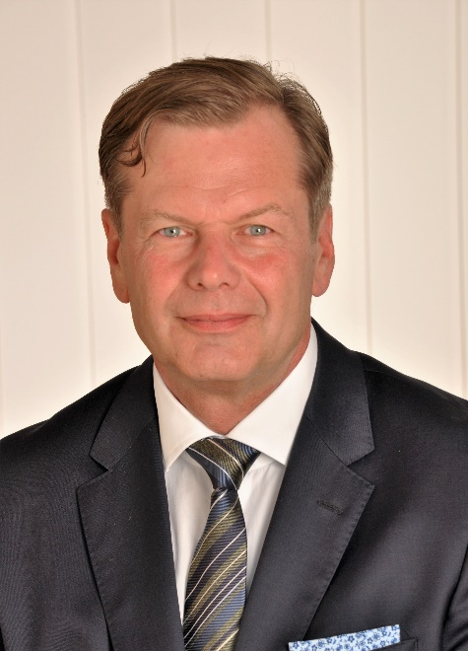 | Dr. Martin Kupiek  Bergstr. 21 | 82152 Krailling  Phone: +49. (0) 89. 48 76 04  Mobile: +49. (0) 151. 1083 5130  E-Mail: martin.kupiek@t-online.de

Profile

___________________________________________________________

Expert in designing and implementing corporate transformation processes to increase growth and improve organizational and leadership agility

Many years of experience in managing divisions, large departments and consulting units in large corporations

Diplom-Kaufmann, MBA and PhD with international education and professional experience in Europe, Germany, USA and Asia

Professional Experience

2011 – today Partner
TCI Transformation Consulting International GmbH, Mannheim, Germany

Projects (excerpt)
- Daimler AG: Optimizing Budgeting Processes, Cost Management, Portfolio development, Service Architecture, Operations and Development support concepts
- Deutsche Telekom: Agile Transformation after Re-structuring, International Delivery Unit (Stream Lead Life Cycle Management processes and Organization Change Management)
- Telecolumbus: B2B Stream-Lead, Post-merger Integration, BSS Migration
- NextiarONE: Design and implementation of a Project Management Office (PMO), incl. Bid- and Claim-Management
- E.On / T-Systems: Sub stream lead Business Support Systems (BSS), Transition & Transformation, responsible for business process design & implementation (Service Order Management), Catalogue, and Billing with 6 direct reports
_____________________________________________________________

2013 – 2015 Vice President Carrier Solutions | Member of Executive Team
TELES AG, Berlin, Germany

- Head of business unit (21 FTE in SW-development, customer service and project management, pre-sales; C4 solutions for carriers)
- Profit and Loss responsibility with approx. 4.2 mil.€ in revenues
- Portfolio includes network infrastructure solutions as well as network interconnection solutions
_____________________________________________________________

2008 - 2011 Partner
Transformation Consulting Group, St. Gallen (CH) and Munich, Germany

- Responsible for the acquisition and delivery of change management projects
- Co-author of talent management study
- Projects in utility and finance industry
_____________________________________________________________

2007 - 2008 Director Regional Management of Managed Services Germany
Siemens Enterprise Communications GmbH & Co. KG, Munich, Germany

- Responsible for the coordination of the German sales regions
- Sales Push project (increase of +42% to 50 mil.€ in revenues)
- Designed and published Managed Services sales and financial handbook on how to sell and operate managed services for sales staff
- 5 direct reports to support ca. 40 regional local Managed Services representatives
- Execution of customer developing plan including coaching of sales staff
- Monitoring of delivery projects, business processes, roles and responsibilities incl. escalation procedure
- Close coordination of the further development of the Managed Services Portfolio with Headquarters
- Responsible for executing project to improve contract profitability
- Development and implementation of Managed Services trainings for all sales managers in Germany (+200)
- Marketing communications: Speaker at several external events (e.g. CeBit, Bitkom) and Live Video Webcast with customers (e.g. Heidelberger Druck, Argillon), published articles in periodicals on Managed Services (e.g. Next Generation Outsourcing, Unified Communication)
__________________________________________________________

2003 - 2006 Business Development Executive (BDE)
IBM Deutschland GmbH, Strategic Outsourcing, Public Sector, Munich, Germany

- Market screening, identification, development and qualification of large innovative service opportunities in the Public, Logistics and Pharma Sector
- Developed and executed new sales strategy aimed at generating new business with public private partnership (PPP) concepts in state / local governments / administrations.
- Responsible BDE for the BOSNet tender (new wireless network for the German police, together with Vodafone), approx. € 220 mil IBM share in 2006 including internal and external coordination of partners (e.g. legal, pricing, suppliers, consultants)
- Successfully created new customer base and developed new projects (e.g. food trace, approx. € 150 mil IBM share)
- Responsible for marketing communication, e.g. representing IBM at various external events (CeBit, Bitkom, American Chamber of Commerce)
___________________________________________________________

1996 - 2003 Executive Manager and Management Consultant
Siemens Business Services GmbH & Co OHG, Consulting Dept., Munich, Germany
Siemens AG, Information & Communications Networks

      - Responsible for the global sales of Outtasking / Outsourcing services.
- Responsible for € 22.5 mil Revenue, € 75.0 mil Revenue € (Plan),
- Revenue growth 25% and cost decrease 10%.
- 4 direct reports (Department Heads) and approx. 130 employees
      - Management of 4 departments (Remote Network Management Operations, Project Management, Smart Home, and Business Development)
      - Managing the current operating Business selling of services to global carrier
      - Led the global INS Project (Integrated Network Services) aimed at fostering the value add service business in the telecom carrier and enterprise sector

      - Responsible for approx. € 2 mil Revenue and up to 15 direct reports
      - Head of CRM Practice and Business Management Telecommunications Industry (responsible for the acquisition, development and delivery of consulting projects.
      - Founder of Change Management and Outsourcing Consulting practice.
      - Head of Partner Management (Initiating and Implementing of Co operations with renowned Management Consulting firms)

1996 – 1996 Senior Consultant
Radermacher & Partner, Headquarter, Munich, Germany

Building a new consulting practice in the field of telecommunications
_____________________________________________________________________

1991 - 1996 Senior Consultant und Project Manager
CSC Computer Sciences GmbH, Munich, Germany

- Responsible for € 1.3 mil. € Project Budget
- People management up to 6 Employees in various project
- Delivered Business Reengineering projects in the telecommunications industry
- Project manager in Asia (billing solution) and implementation of an finance software at CSC in Europe
- Responsible delivery of projects in the field of business process re-engineering, -design and process cost
- Supported founding the outsourcing unit of CSC in Germany and was appointed finance manager with full financial authority (Bank- u. Handlungsvollmacht)
___________________________________________________________

1989 - 1991 Management Consultant
Digital Equipment GmbH, Headquarter Munich, Germany

- Development of consultative sales methodologies to support sales and account teams to improve and enhance current sales strategies (Integration of Strategy and Technology)
- Supporting of key account managers and pre sales support

__________________________________________________________________________________

Trainings

Regular participation in seminars on process consulting e.g. organizational change management, conflict management, group dynamics, and effective communications

Finance for Executives; ACE = Achieving Finance and Controlling Excellence Program

Negotiating Skills II (Huthwaite), Leading@IBM, Internal Marketing, CxO Sales Enablement – Selling to C-Level Executives

______________________________________________________________________

Education

2009 - 2016 Doctor of Philosophy (PhD) | University of Innsbruck, Austria

1986 - 1988 Master of Business Administration (MBA) | University of Vermont, USA

1980 - 1986 Diplom-Kaufmann | Universität Dortmund

